
AEROSPACE ENGINEERING
& ENGINEERING MECHANICS

SAE Aero Design® East 2006

University of Cincinnati AeroCats
Team #006

Report Submission Date: March 10, 2006
Competition Dates: April 21-23, 2006

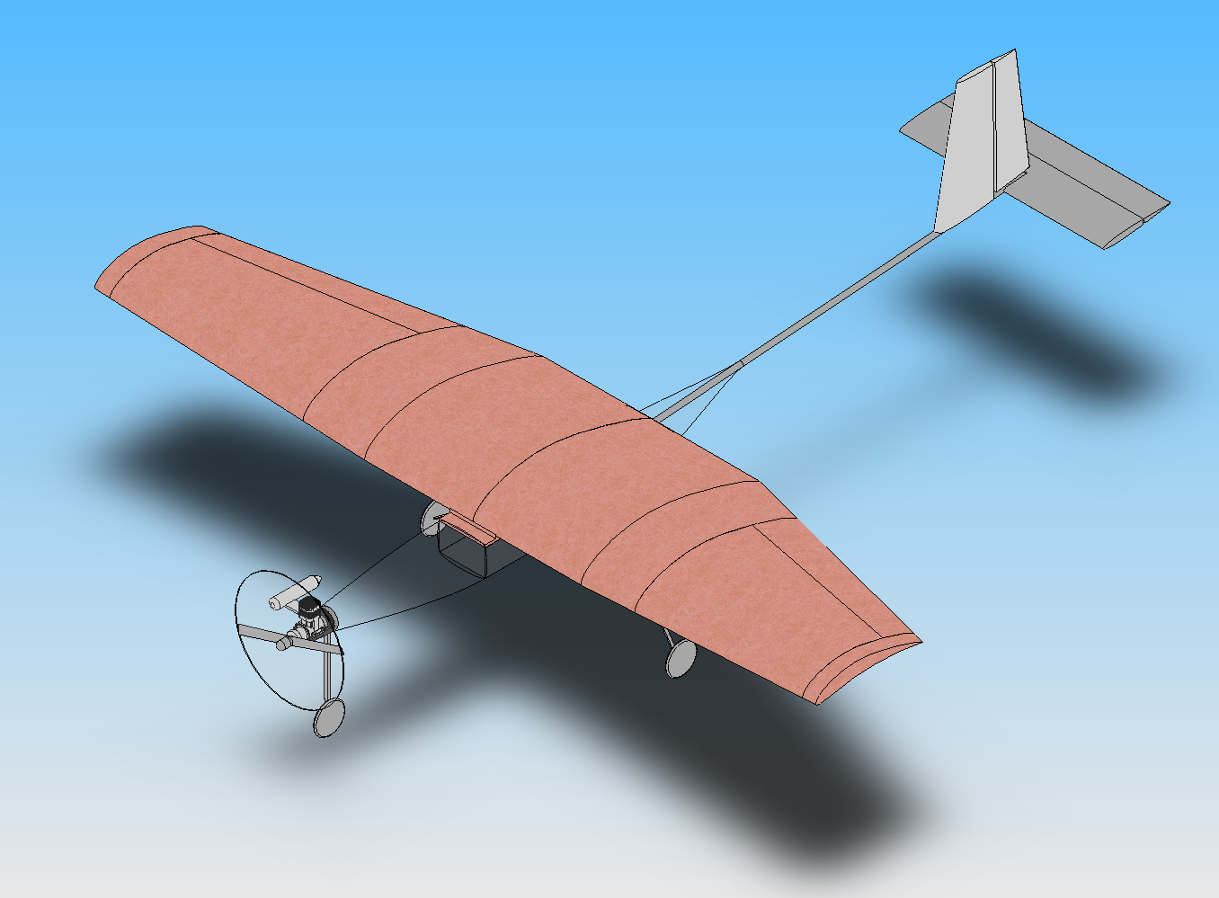

Design Team
Marshall Galbraith Yvette Geyer Josiah Hauck
Ryan Jones Michael List Matthew Mangano
Brian Minda Elise Minda Michael Perrino
John Reed Jr.

Advisor
Dr. John Livingston

TABLE OF CONTENTS PAGE
STAEMENT OF COMPLIANCE i
TABLE OF CONTENTS ii
PAYLOAD PREDICTION CHART iv
1.0 INTRODUCTION 1
2.0 MODELING SUMMARY 1
3.0 AERODYNAMICS AND WING CONFIGURATION 1
3.1 Initial Configuration 2
3.2 Wing Configuration Refinement 2
3.3 Airfoil Selection 5
3.2 Aircraft Computational Fluid Dynamics 7
3.3 Total Aircraft Aerodynamics 8
4.0 STRUCTURES, WEIGHTS, AND BALANCES 10
4.1 Structural Design and Fabrication 10
4.1.1 Wing Design 10
4.1.2 Fuselage Design 13
4.1.3 Connection Points 13
4.1.4 Landing Gear 14
4.4 Components and Total Weight Summary 15
5.0 PROPULSION 16
6.0 STABILITY AND CONTROLS 18
6.1 Flight Stability and Tail Sizing Optimization 18
6.2 Control System 22
7.0 PERFORMANCE AND OPTIMIZATION 22
7.1 Trade Studies 23
7.2 Aircraft Performance 23
8.0 DRAWING 24
9.0 REFERENCES 25

THIS CHART NEEDS TO BE DOUBLE CHECKED
PAYLOAD PREDICTION CHART AEROCATS, UNIVERSITY OF CINCINNATI
TEAM #006

INTRODUCTION
The Society of Automotive Engineers Collegiate Design Series was created to enable students to apply the knowledge obtained in the classroom to real world problems. The Aero Design® Competition requires teams to design, build, and fly aircraft given specific design constraints. For the 2006 competition, these constraints include a maximum take-off distance of 200 ft, a required wingspan of 2.4m, a maximum landing distance of 400 ft, and the requirement to hold a 5”x3”x16” payload box. In addition, the aircraft must use a stock OS 0.61 FX engine with an E-4010 muffler and fueled by the competition officials. The propeller must maintain a 1:1 angular velocity with the engine. The objective is to lift the most weight possible.
To accomplish the multifaceted task of creating an aircraft to meet these design criteria, the Aerocats from the University of Cincinnati (UC) divided into several groups, each with specific responsibilities. The modeling group produced technical drawings to aid in construction. The aerodynamics group was responsible for the planform details. The structures, weights, and balance group performed structural and component analyses to reduce aircraft weight while maintaining structural strength and to achieve a proper Center of Gravity (CG) location. Engine testing and propeller selection was conducted by the propulsion group. The stability and controls group calculated the aircraft’s stability characteristics and constructed a control system to satisfy the mission criteria. Finally, the performance group calculated ground roll and climb characteristics.

MODELING SUMMARY
The final design to be used in the competition may be viewed in the Drawings section following the discussion of design evolution and analysis. In brief, the aircraft may be characterized as follows. The primary design is a traditional aircraft with slight modification to the fuselage and the wing. Tricycle landing gear and standard control surfaces are employed.

AERODYNAMICS AND WING CONFIGURATION
Prior to initiating other aspects of the design process, an assessment of aerodynamic concerns was crucial in determining the preliminary design, specifically in terms of the wing configuration. As such, aerodynamic analyses were conducted using XFOIL, XFLR5, and a full 3-dimensional simulation was computed using CFD++.

Initial Configuration
At the onset of the design process, a number of options were considered, among which were a conventional rectangular wing, a biplane, a flying wing, and a joined-wing configuration. However, both the joined wing and biplane configurations were quickly ruled out due to their structural complexities. A flying wing and conventional configuration was further investigated. In order to produce a flying wing, a high lift airfoil with a near zero moment would be required. In addition, a configuration with the required moment arm for pitching control surfaces was highly impractical to produce for a flying wing configuration. Hence, a conventional configuration with a single wing, horizontal and vertical tail, and a fuselage, was chosen due to the simple construction and analysis associated with this configuration.

Wing Configuration Refinement
The initial main wing analysis was performed using XFLR5. XFLR5 is a code which incorporates XFOIL, Vortex Lattice Method (VLM) and Lifting Line Theory (LLT) into one package, allowing both airfoil as well as wing analysis to be performed in a single environment. Caution must be taken when deciding on which method to use when analyzing a wing. The VLM method will work for any wing configuration, however because it is a linear method it does not predict any stall behavior. The LLT on the other hand generates a lift distribution based on the airfoils used, and hence accounts for non-linear effects and captures the stall if the wing. The down side to this method is that it is not accurate when large amounts of sweep on the wing. Furthermore, because the VLM method calculates pressure distributions it more accurately predicts moments than LLT. For our analysis, LLT was used to calculate lift and drag on the wing, and VLM was used to verify that any sweep angles tested did not invalidate the LLT. In addition, in order to make valid comparisons between wing configurations, the airfoil and area of each wing was held constant. The airfoil was a simple NACA 0012.
The ideal wing has a perfectly elliptical lift distribution, which leads to an approximately 7% reduction of induced drag compared to a rectangular wing of the same aspect ratio. There are several ways to achieve an elliptic lift distribution, one of which is to construct an elliptical wing. However, such a wing requires complicated manufacturing techniques. In addition, an elliptical wing crates a constant lift coefficient over the span which leads to entire wing simultaneously stalling with complete a loss of control of the aircraft. A near elliptical lift distribution can be achieved by applying a 0.45 taper ratio, or sweeping the wing forward 22°. In order to achieve a near elliptical lift distribution, while creating a desirable coefficient of lift distribution, a combination of sweeps and taper ratios was investigated.
As see in Figure 3.1, a taper ration which originates from the center of the wing, cause a reduction if lift coefficient at the center of the wing with the maximum lift coefficient occurring midway between the center and tip on each side of the wing, which concise with the aileron location. This type of a lift coefficient distribution would cause the wing to initially stall at the aileron location before the root of the wing stall; hence, the wing will loose aileron control before the entire wing stalls and subsequently causing a loss of control of the airplane. By introducing a constant chord section at the root, the lift coefficient at is increased at the root of the wing, however the lift coefficient still remains high at the ailerons. This was corrected by utilizing a forward sweep on the tapered section of the wing. Hence, the final lift coefficient distribution has a maximum lift coefficient near the root of the wing causing this section to stall before the ailerons and producing a wing which maintains controllability during the initial stages of a stall.
Traditionally, wings are swept back on aircraft in order to decrease the effective chord to thickness ratio and hence increase the critical Mach number for high speed flight. Forward swept wings have been rarely used on practical aircraft due to the complicated structural requirements. During a pitch up motion, a backward swept wing will naturally twist down at the wing tips causing a reduced Angle of Attack (AoA) and forcing the desirable feature of the stall to initially occur at the root of the wing. However, for a forward swept wing, the wing tips tend to twist upward causing an increased AoA near the tip, hence causing the loss of aileron control. Fortunately, due to the relatively small load and size of the wing at hand these problems do not pose a large concern.
A
B
C
Figure 3.1: Lift coefficient distribution for various wing configurations
Several configurations were investigated with different taper ratios, constant chord sections, and forward sweeps. The final wing configuration in Figure 3.2 has a constant chord at the root reaching 25% of the wing semi-span, a taper ratio of 0.6 at the outer section, and a quarter chord forward sweep on the tapered section of 8°. The wing span is the set 94.488 in, with a Mean Aerodynamic Chord (MAC) of 20.6 in, and wing area of 1901 in². During the stability and controls investigation of the airplane, a 7° dihedral was introduced on the tapered section. Details for this requirement are presented in the stability and controls section.
Quarter Chord
Elliptic Distribution
0.25 b_{w} / 2
8°

Figure 3.2: Final main wing configuration

Airfoil Selection
Because this aircraft does not have a long range requirement, and sole purpose is to acquire a maximum payload fraction, only high lift airfoils were considered during the design process. The highest lifting airfoils are generally shaped similar to a turbine blade with high cambers and maximum thicknesses near or forward of the quarter chord, and addition they are generally plagued with a high moment. These airfoils were initially evaluated using XFOIL and available experimental data in order to reduce the number of airfoils to a select few. Some airfoils were excluded from a manufacturing point of view due to an extremely thin portion of the airfoil, typically located near the trailing edge (e.g. the Selig S1223). Far too many airfoils were evaluated to include them all in this report, but a comparison of two high lift airfoils is presented in order to exemplify the process. The Eppler E423, and the Althaus AH 94-145 in Figure 3.3 are compared here, each airfoil with a maximum lift coefficient of 1.9 at 13° AoA and 1.6 at 9° AoA respectively.
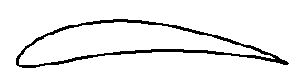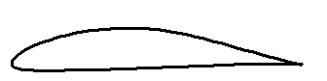
E423
AH 94-145
Figure 3.3: The Eppler E423 and Althaus AH 94-145 airfoils

Once the number of airfoils was narrowed down, the wing each airfoil required was also accounted for in the comparison. From previous experience with the OS 0.61 FX engine, an estimated takeoff speed of 40 fps, as well as maximum total takeoff weight of 32.5 lbf was used to calculate the required wing area for a given airfoil. Although 32.5 lbf is above not the anticipated total takeoff weight, it was used in order to account for imperfections in both design and construction of the aircraft. The lift of lift coefficient for each airfoil was calculated by dividing the maximum lift coefficient from the airfoil by 1.2², because lift of velocity typically is 1.2 times the stall speed. The required wing area was then calculated from the lift of coefficient and takeoff speed based on equation .
$S_{w}=\frac{W_{\text{max}}}{0\text{.}5{ρV}_{\text{LO}}^{2}C_{L_{\text{LO}}}}$ ()
Here, W_{max} is the maximum takeoff weight, V_{LO} is the lift of speed, C_{L_LO} is the lift off lift coefficient, and ρ is the air density.
Once the proper wing areas were calculated for each airfoil, the wings were again analyzed in XFLR5. [Why Lift instead of Cl????] Lift vs. drag of each of the wings is illustrated in Figure 3.4, where it is evident that the lift and drag of both wings are identical once the lift exceeds approximately 19 lbf. This point corresponds to a 0° and 3° AoA for the E423 and AH 94-145 wing respectively. In other words, for positive angles of attack, both wing have identical lift and drag performance, with only a shift in angle attack. However, due to the higher lift coefficient associated with the E423, the E423 wing only requires 84% of the wing area of the AH 94-145 wing. Similar results were found when other airfoils were compared to the E423. Therefore, because the E423 both has a higher stall angle and requires a smaller and lighter wing, it was chosen as the airfoil of the main wing.
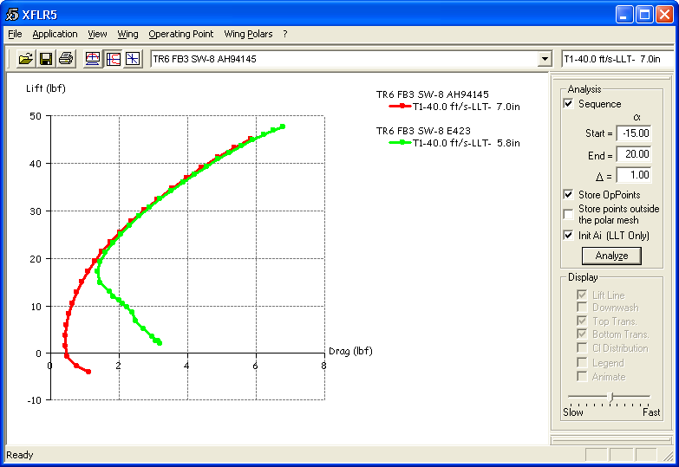
AH 94-145
E423
Figure 3.4: Drag polar for wing with two different airfoils

For the horizontal and vertical tail, a NACA 0012 airfoil is utilized. This airfoil was chosen because of its simplistic construction as well as satisfying minimal interior space for servo mounting.

Aircraft Computational Fluid Dynamics
Computational Fluid Dynamics (CFD) is a viable and comprehensive way to compute 3-dimensional pressure distributions over complex geometries which would normally require extensive calculations over a much simplified geometry. Using industry tools for automotive and airplane design and analysis, it was possible to solve non-linear equations over the actual surfaces expected to result from the construction process.
After fully designing the aircraft, a solid model was created in SolidWorks. Exported as a database, the geometry was then imported into Gridgen, a meshing software for developing computational domains for finite difference and finite volume calculations. Adequate resolution for an incompressible, viscous flow was obtained with an unstructured, single block mesh comprised of over 2 million elements. Using Metacomptech’s CFD++ it was unnecessary to create a well defined, structured boundary layer. The wall function scheme required only that points be specified within a few millimeters of the surface for the desired resolution. In order to match the analysis previously performed on the aircraft design, the propeller was ignored. The non-surface boundary conditions at the far-field (where no flow disturbance would be detectable, typically 50 to 75 wing chord lengths) were represented by a pressure-temperature-velocity boundary condition, which used appropriate quantities to solve the elliptic, incompressible Navier-Stokes equations.
Using well developed methods for initialization and flow solving in CFD++ it was possible to obtain pressure distributions on all surfaces of the aircraft, including the landing gear and engine components (though the prop was ignored). This allowed an overall C_{D} and C_{L} for the aircraft to be determined at a variety of angles of attack. The obtained parameters were then compared to the previous analysis.
After correlating the CFD analysis with the aircraft performance data, boundary conditions were added to appropriately simulate the pressure rise and induced swirl of a fan. The data collected would then be used to make educated estimates for the total vehicle performance.

Total Aircraft Aerodynamics
After determining the final aircraft configuration, a series of parametric models were developed in MathCAD, which provided the necessary aerodynamic characterization of the total aircraft. In order to maintain a parametric model, the drag polar produced from XLFR5 were not used directly in the MatchCAD models, but rather as a guideline when tweaking parameters. For instance, the total drag for each lifting surface was constructed by summing the profile drag of the airfoil with the induced drag. The drag of the main wing is depicted in Figure 3.5 as an example of this. Once the drag for each component of the aircraft had been established, the total trimmed aircraft drag was produced as the sum of all components through the “D/q” method as seen in Figure 3.6. Similarly, lift was summed up over the wing and horizontal tail, which gave the final full aircraft lift curve in Figure 3.7 and drag polar in Figure 3.8. The trimmed condition was achieved by calculating the required elevator deflection required at each AoA in order to produce a zero moment.
A highly favorable feature of the E423 airfoil is high AoA which stall occurs, as seen in Figure 3.8, occurs at about 19° AoA. Furthermore, the E423 maintains a high lift coefficient for AoA going down to -5°. This gives a desirable wide effective AoA operating range for the aircraft.
[There has to be something else to say about the total aircraft aerodynamics, but I can’t think of anything.]
Figure 3.5: Drag buildup for the main wing

Figure 3.6: Trimmed total drag build up | Figure 3.7: Trimmed and untrimmed total lift

Figure 3.8: Drag polar for the aircraft | Figure 3.9: Lift over drag vs. AoA

STRUCTURES, WEIGHTS, AND BALANCES
The purpose of the structures group was to build the lightest possible airplane, with minimal strength, in order to survive the loadings experienced during flight mission maneuvers and landing. Minimizing the complexity of the load path through the airframe was also a controlling factor of the structural design. Composite materials were chosen primarily due to their high strength-to-weight ratio. Prior UC competition aircraft utilized composite materials in their design. These previous lay-up and construction methods were studied and considered while preparing the current structural design.

Structural Design and Fabrication

Wing Design
The wing design process involved multiple levels. Initially, different approaches to wing design were considered: a box spar, a foam core with composite skin, or a composite, foam-filled D-spar. The box spar was deemed unacceptably heavy and difficult to construct. The foam core with composite skin would weight too much for the main wing, but was adopted for use with the horizontal and vertical tail. The composite, foam-filled D-spar design was chosen for the main wing.
The main wing D-spar design was slightly modified as construction was attempted. A previous UC competition aircraft wing design proved to further reduce weight as the foam in the D-spar had been reduced to only a small section used to aid in the lay-up of the composite spar. This hollow, semi-monocoque design was chosen for the design, though two necessary modifications were made. The first was to change the skin material from monokote to a thin layer of fiberglass. This adjustment was a trade-off. It increased the weight of the main wing, yet it also more closely fit the actual curve of the chosen airfoil when compared with the monokote. The improved aerodynamic performance of the fiberglass covered wing outweighed the slight increase in weight. The second modification was to change the aileron design from balsa wood ribs with a monokote covering to hollow foam core covered with fiberglass. This would simplify the construction process for the ailerons as they to not have a simple rectangular geometry. Therefore, the finalized main wing design would entail the following: a spanwise central spar with Graphlite carbon rods for spar caps supported by a fiberglass shear web wrapped about a minimal amount of foam for lay-up assistance, balsa wood ribs, foam ailerons, and fiberglass skin. Ultimately, the main wing final design resulted in the lightest possible wing with simple construction and maximum aerodynamic performance.
The main wing spar was analyzed using normalized distributions. The loading distribution is approximated using the Schrenk approximation and is assumed to be applied directly on the spar (neglecting wing twist and not accounting for the effects of sweep). Given these assumptions, this particular loading distribution is shown in Figure 4.10 with the corresponding moment and shear distributions. Main structural concern was placed on cantilever bending of the wing and the associated bending stress at the center of the wing. Figure 4.11 shows that main wing spar is will be completely structurally sound in bending as the maximum allowable stress far surpasses any bending stress the main wing may experience, particularly at the center of the wing. This excess structural strength in bending is acceptable as the composite lay-up is as light as possible while maintaining ease of construction and minimal cost of materials; the Graphlite rods used as spar caps were purchased in bulk and will also be used as fuselage booms.
Figure 4.10: Main Wing Spar Approximated Loading Distributions

Figure 4.11: Main Spar Bending Stress Using C-channel Beam (Graphlite carbon rod spar caps and fiberglass shear web)

The horizontal and vertical tail designs both utilized a foam core, which was slightly hollowed out in order to reduce weight. Each was separately covered in fiberglass fabric. A notch was cutout at 60% of the chord length to create an elevator for the horizontal tail and a rudder for the vertical tail.

Fuselage Design
After successful design and fabrication of the main wing using composite materials, similar techniques were applied to the fuselage construction. The fuselage shape was developed by generating bulkheads shaped by using spline fits to minimize cross-sectional area about the payload bay. After being appropriately sized, the bulkheads were laid out in a wood template at the suitable axial stations and a Graphlite carbon rod was laid at each corner in a minimum-energy bend to run from the engine mount at the nose to the tail boom.
Carbon fiber bulkheads were used to bear the loads transmitted to the fuselage from the tail and wing loading. Between each bulkhead, hollow foam was placed to create the fuselage shape. Four Graphlite carbon rods, of dimension 0.057” x 0.177” (same size Graphlite carbon rods used as main wing spar caps), were used as fuselage boom rods to increase the structural stability of the fuselage and reduce weight. Fiberglass cloth was used as skin for the fuselage covering.

Connection Points
The structural design concern that posed the greatest difficulty was to properly engineer the connection points. To ensure a strong and stable airplane, all connection points had to be designed with consideration of load paths as well as the integrity of each specific joint. This was relatively simple for the fuselage, because the bulkheads provided natural connection points, as their placement had been initially designed for this purpose. Attachment of the main landing gear to the back bulkhead was achieved by integrating the landing gear into an appropriately angled carbon fiber bulkhead about the payload bay using a carbon fiber cloth and sewn carbon fiber toes. The front landing gear was similarly integrated into the front bulkhead. The fore end of the tail boom was inserted through the back bulkhead of the fuselage and the fuselage boom rods were wrapped to the boom with composite fiber toes and cloth. The aft end of the tail boom was inserted into the leading edge of horizontal tail and the vertical tail was placed atop the boom. Composite material was then wrapped about the tail system and the tail boom to ensure torsional rigidity.

Landing Gear
For the main landing gear struts, steel and extruded Graphlite carbon rods were compared. Extruded Graphlite carbon rods were chosen as the construction material due to their inherently high strength-to-weight ratio. These struts were manufactured by stacking two layers of carbon fiber rods, each measuring 0.125” x 0.5”, creating a spring-leaf gear system which met the analyzed landing strength requirement discussed in the following paragraph. The main gear was inserted into a hollow aluminum tube which bent into the axle of the 4” aluminum wheels. A more traditional spring steel strut was used for the front landing gear with the same aluminum wheel.
The necessary dimensions of the landing gear were calculated as a function of the stroke and the bending stress. The analysis was conducted assuming the aircraft was at a worst case landing scenario of a 4-g loading (where the landing gear sees a 3-g loading and the wing sees a 1-g loading) while maintaining an adequate safety factor for stroke and bending stress. Equation is the equation for the stroke of a solid-spring gear leg with a built-in safety margin.
$S=\frac{V_{\text{vertical}}^{2}}{2 g η N_{\text{gear}}}+1 \text{in}\text{.}$ ()
This produces a stroke (S) value of about 8.5 in. Then equation and were used to calculate the unknown dimensions of the landing gear, the thickness and the breadth, from the known values of the stroke and yield stress for the Graphlite carbon rods.
$S=\frac{F_{S} ({\text{sin}}^{2}θ) l^{3}}{3 E I}$ ()
$σ=\frac{M_{\text{max}} c}{I}\frac{1}{F\text{.}S\text{.}}$ ()
With a bending stress factor of safety (F.S.) of 1.5 and a perpendicular load (FS) of 48.75 lb., the necessary dimensions for the landing gear are as follows: a strut length (l) of approximately 19”, a front angle (θ) of 57º from the vertical, a thickness of approximately 0.125”, and a breadth of approximately 1.0”.

Components and Total Weight Summary
Table 4.1shows the weight of each component and the position of that component relative to the aerodynamic center. The weights of the components were obtained using a combination of manual weighing of materials and approximating weights of the aircraft structure. The position of the specific components were adjusted such that CG of the aircraft is located 1.4 inches behind the aerodynamic center. The payload bay is located directly over the CG do that changing the weight of the payload has a minimal effect to the overall performance of the aircraft.
Table 4.1: Component weights and CG summary

[Missing a payload here, and total weight is not final]
Table 4.2 shows the empty weight and maximum weight of the aircraft as well as an estimate of the moments of inertia of the aircraft. The moments of inertia of the aircraft were approximated using the weight and location of each component as well as the approximate moments of inertia of a few of the larger components (e.g. the wing).
Table 4.2: Total takeoff weight and aircraft moments of inertia
Takeoff Weight | Ixx | Iyy | Izz
30 lbf | 0.48 slug∙ft² | 1.31 slug∙ft² | 1.71 slug∙ft²

PROPULSION
The engine for the aircraft was set by the rules committee as the O.S. 0.61 FX Engine with the E-4010 muffler. The engine cannot be modified, but the propeller producing the maximum amount of thrust can be chosen. In order to determine the operating characteristics (torque, power, and thrust) of the engine, experimental tests were conducted. The experimental data was corrected to the conditions of a standard day which are 60 deg-F, 29.92 in-Hg, and dry air. The engine was mounted into a Dyna-Torque test stand to determine the torque at various RPMs and thus, the power. Error: Reference source not found shows the torque and power produced by the engine for a standard day when subjected to different resistances resulting in a range of RPM. The curves in the figures represent a correlation of a theoretical model to the experimental data. This theoretical model was based on manufacturer’s specifications and piston engine theory from Heywood.

Figure 5.12: Torque and Power produced by the O.S. 0.61 FX Engine

Figure 5.13: Data and theoretical thrust curves for various propeller sizes and pitches

Figure 5.14: Matched power and thrust for the engine and propeller with theoretical performance at a range of forward velocities

Several propellers were tested with the engine to determine the thrust being produced. Fifteen two bladed propellers were tested with the diameters ranging between 11 to 15 inches. The tested propellers were a combination of wood and nylon from several manufacturers. The blade pitch measured at 75% of the radius varied. The thrust for each propeller was corrected for a standard day and plotted in Error: Reference source not found as a function of RPM. Experimental testing showed the propeller which produced the most thrust was 14 inches in diameter with a 5 deg pitch (14x5). The data point corresponding to this propeller is circled in red on the figure. The 14x5 propeller produced 9.14 lbf of thrust at 11400 RPM. The curves in the figure were calculated using a simple parametric propeller model based on the representative blade theory from Von Mises. Each curve in Error: Reference source not found corresponds to a different propeller diameter while any point along a curve is a different representative blade pitch. The representative blade pitch is measured from zero lift. The representative blade pitch of the 14x5 propeller is 12.7 deg. The model was correlated to match the experimental data fro the 14x5 propeller.
With the models correlated to the test data, the model can be used to determine the RPM that the engine and prop run together using an iterative method. Using the engine and prop matched RPM, the power and thrust the engine and propeller produce together was determined. Error: Reference source not found shows these values as functions of velocity. Error: Reference source not found shows the thrust at zero flight velocity to be 8.91 lb. This is slightly less than the thrust test result, displayed in the figure by the red point, since the RPM found when matching the engine and prop is 10500. Error: Reference source not found also shows that the thrust decreases with increased aircraft velocity. The data produced by Error: Reference source not found was used by the performance group to help determine detrimental flight characteristics.

STABILITY AND CONTROLS
The goal of the stability and controls group is to calculate the aircraft flight mechanics and construct a control system that enables the aircraft to perform the necessary mission. The operating environment of the aircraft is at low speed, low altitude and the mission profile requires minimum maneuvering. The aircraft is also required to be easy to control and have robust predictable pitch stability for different payload configurations.

Flight Stability and Tail Sizing Optimization
The aircraft’s flight stability analysis was broken up into two parts: static and dynamic stability. In order to achieve dynamic stability, static stability must first be obtained. In static stability, longitudinal stability is the most important direction to be considered. In order for the aircraft to have static longitudinal stability slope of the pitching moment verses alpha curve must be negative. Figure 6.15 shows the pitching moment coefficient (C_{m}) vs. AoA for the design (CG) and ± 1.0 inch from the design CG, as well as the pitching moment with the CG located at the Neutral Point (NP). The placement of the CG was calculated by first evaluating the required incidence angle of the horizontal tail for C_{m} = 0 during takeoff. Once the incidence angle was calculated, the NP was determined and the CG positioned at 10% MAC in front of the NP. In general, the a desired CG location lies between 5% and 10% MAC, therefore, the design of 10% MAC allows for a margin of error in the manufacturing process.
In order to minimize the weights of the aft components of the aircraft, namely the horizontal and vertical tail, and to provide the desired stability for the aircraft, several analyses were performed. These included appropriate dihedral of the wing’s outboard tapered sections, proper tail boom length, and sizing of the horizontal and vertical tails. The primary trade was for stability. As such, various quantities relating to the longitudinal and lateral stability were plotted as a function of the parameter being varied. The new geometry was produced by the MathCAD models and formatted for use in AVL. Unfortunately, due to XFLR5’s inability to compute on multiple surfaces, there was not a chance to check multiple computation methods. The stability derivatives computed by AVL were then imported and analyzed in MathCAD to give the pitch, Phugoid, short period, and Dutch roll damping ratios; the spiral stability time to half, and the Dutch roll natural frequency.
Once the static margin model was established, it was desired to finalize the wing planform design by applying the dihedral necessary to obtain spiral stability with a short half time. Although single-variation study was desired, the importance of understanding how the stability performance behaved as the tail location was changed was taken into account. For small dihedral it was seen that the total aircraft configuration was spirally unstable with a small time to double. Increasing the dihedral to the stability point and beyond, a trend line was formed for the time to double time to half, as this was the only parameter that varied noticeably. The study was repeated for multiple tail locations, including 2.8, 3.0, and 3.2 MAC from the AC of the wing, though the vertical and horizontal tail volume coefficients were held constant at 0.03 and 0.4, respectively. The obvious result was that a smaller dihedral angle was needed as the tail boom was extended. In addition, roll stability is primarily determined by the restoring rolling moment as a function of sideslip (β). In order to be considered statically stable in roll C_{lβ} must be negative, with the wing dihedral as the main contributor to C_{lβ}. Since the aircraft configuration involves a low wing design; the fuselage contributes a negative dihedral effect. As such, a dihedral angle of 7° was all that was needed to obtain roll and spiral stability.
Next, various trades were performed where each of the horizontal tail volume coefficient (HTVC), the vertical tail volume coefficient (VTVC) and the length of the tail boom (again measured from the AC of the wing) were varied independently to create multiple stability trends. Because the horizontal tail contributes a downward acting force in order to counteract the moment of the main wing, a minimal horizontal tail was desired while maintaining a critical damping pre request of the pilot. From this study, a HTVC of 0.4 with 3.2 MAC tail boom was found to give a minimal down force with an adequate damping ratio as see in Table 6.4. Furthermore, when holding the HTVC and tail boom constant, a VTVC of 0.045 was determined suitable. This is consistent with historical single prop airplanes which typically have a VTVC of around 0.04Error: Reference source not found.
Once the static margin and horizontal tail volume coefficient has been established, the elevator must be sized such that the pitching moment can be controlled over the entire range of flight. After a few iterations, an elevator chord fraction of 0.4 and a span fraction of 1.0 was found to give adequate control as seen in Figure 6.16. Here, the C_{m} is plotted vs. AoA for three elevator deflections: -10°, 0°, and 10°. Clearly, the elevator is capable of shifting the C_{m} curve such that the curve crosses the C_{m} = 0 line at any point between -5° and 23°, which provides complete control of the aircraft because both angles are outside the effective AoA range. The rudder was sized using AVL to provide appropriate directional control in a sideslip with a chord fraction of 0.4 and a rudder span fraction of 1.0. In order to achieve roll control an aileron chord fraction of 0.25 and aileron span fraction of 0.25 were determined, which with a 15 deg deflection yielded a roll rate of 100 deg/s during takeoff speed and 150 deg/s at maximum speed.
Table 6.3 lists the yaw, pitch, and roll derivatives calculated for the aircraft configuration. [Can we say something about these derivatives?]
Figure 6.15: C_{m} vs. α for moving CG | Figure 6.16: C_{m} vs. α for elevator deflections
Table 6.3: Pitch, Yaw, and Roll Derivatives
C_{mα} | C_{mq} | C_{mδe} | C_{nβ} | C_{nδr} | C_{lβ} | C_{lδa}
-0.52 | -8.85 | 1.16 | 0.12 | -0.071 | -0.08 | 0.17

The dynamic stability focuses on both the lateral and longitudinal flying qualities. The aircraft meets the Level I; Class I; Category B [Why must it meet these qualities?] flying qualities for lateral and longitudinal dynamic stability as given by reference []. The longitudinal Phugoid and short period modes were used to determine dynamic longitudinal stability. The pure pitching motion dampening ratio and frequency were evaluated to ensure the aircraft was not under damped. The dampening and natural frequencies for the Phugoid and short period modes can be seen in Table 6.4.
The lateral dynamic stability was determined by the spiral mode and Dutch roll. Our aircraft does not have spiral stability. This however, is typical of most aircrafts. Our aircraft has a long time to double amplitude allowing for the aircraft to be controllable even though it’s not spirally stable. The time to double amplitude for stability was twenty seconds as given by reference [Error: Reference source not found]. The current aircraft has a negative time to half which is also acceptable. The dampening and natural frequencies for the Dutch roll can be seen in Table 6.4.
Table 6.4: Longitudinal and Lateral Dynamic Stability Components
 | Phugoid | Short Period | Pure Pitching | Dutch Roll
Required | 0.04 < ζ | 0.35 < ζ < 1.3 | 1.0 < ζ | 0.08 < ζ; 0.4 < ω
ω (1/s) | 1.459 | 8.773 | 3.706 | 3.5
ζ | 0.08 | 1.10 | 1.185 | 0.94

Control System
The radio control system is built around a Futaba 9CAP controller and receiver unit. Separate servos were chosen for the left and right ailerons to eliminate long control linkages. The large size of the aircraft configuration and limited space for transportation to the flight line required the wings of the aircraft to be removed and stored parallel to the fuselage. Due to separate segments, a control linkage system design was needed to limit the fieldwork necessary to assemble the aircraft for flight. The left and right halves of the wing contain the servos for their respective ailerons. Similarly, the vertical and horizontal tail sections contain the rudder and elevator servos. In order to have the most robust and rigid control linkage possible four main control surfaces (left and right ailerons, elevators, and rudder) are connected to their respective servos using “horn” linkages and short rigid push-rods. This arrangement is typically found on the aileron linkages for smaller R/C aircraft. The forward fuselage contains the receiver, the battery pack, the nose gear servo, and the engine throttle servo. The nose wheel and throttle are controlled using flexible rod linkages. The required torque for control surface deflection of these servos can be seen in Table 6.5.
Table 6.5: Required Servo Torque
 | Ailerons | Rudder | Elevator
Required Torque (oz∙in) | 123 | 20 | 33

PERFORMANCE AND OPTIMIZATION
Finally, by incorporating the results from each of the previous analyses, the performance of the design was evaluated and adjusted, in order to satisfy the flight requirements. Of particular concern, for the prescribed mission, were the design weight (especially the payload weight) and the ground roll length required to reach takeoff. Additionally, a minimum climb rate was stipulated. Through an iterative process, a series of Mathcad models were employed to study the influence of main chord length upon the feasible design weight. Lastly, the performance of the final design was determined.

Trade Studies

Aircraft Performance
After determining the final configuration, estimates of the aircraft performance were readily available from the aforementioned parametric models. A brief summary of the key results follows immediately below. Note that in Figure 7.17 and 7.18, curves for two alternate design weights are provided for comparison, whereas Figure 7.19 and 7.20 represent only the final design behavior.
First, Figure 7.17 illustrates the increase in ground-roll distance (essentially, the movement of the aircraft down the runway) as the velocity increases. Most importantly, the lift-off velocity of 40 ft/sec is reached well within the ground-roll limit. Next, the V-N diagram (Figure 7.18) indicates a maximum wing loading of 3.22 g’s, which occurs only at velocities above 60 ft/sec.
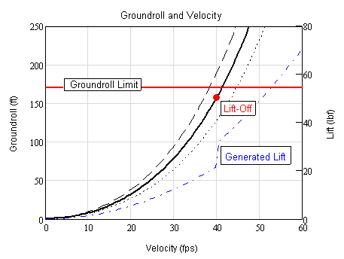 | 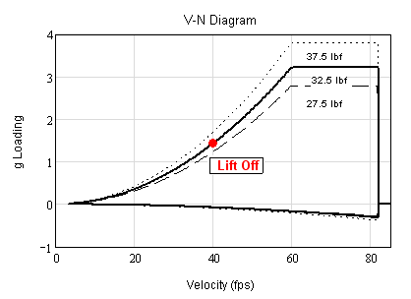
Figure 7.17: Ground-roll vs. Velocity | Figure 7.18: V-N Diagram
Lastly, the angle and rate of climb are also plotted as functions of velocity (Figure 7.19 & 7.20). In both cases, the values are zero at low velocities, during the takeoff run. Upon reaching the lift-off velocity (40 ft/sec), the aircraft leaves the runway with a climb angle of roughly 3 degrees and a climb rate of 206 ft/min. Thereafter, the climb angle increases to a maximum of roughly 4.5 degrees, at the optimum climb condition. The corresponding maximum climb rate is around 400 ft/min, for velocities between 60 to 70 ft/sec. The actual operation of the aircraft may not reach these performance conditions, but the analysis indicates that the aircraft will provide acceptable takeoff and climb performance for competition purposes.
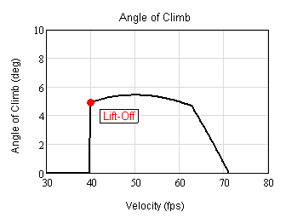 | 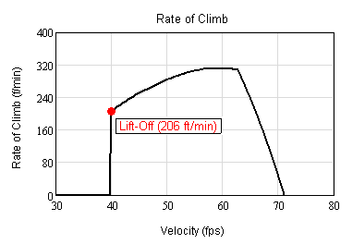
Figure 7.19: Climb Angle vs. Velocity | Figure 7.20: Rate of Climb vs. Velocity
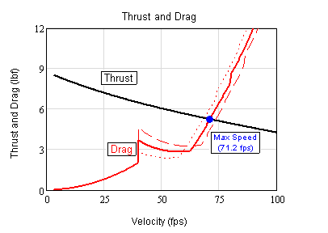

DRAWING

REFERENCES

XFOIL Subsonic Airfoil Development System, Ver. 6.94, M. Drela, Massachusetts Institute of Technology, Boston, MA, 2001.
XFLR5, Ver. 2.01, André Deperrios, http://www.geocities.com/xflr5/xflr5.htm, 2005.
CFD++, Ver 4.2.1, Metacomp Technologies Inc., Agoura Hills, CA, 2004.
Raymers Book
MathCAD, Ver 13.0, Mathsoft Engineering & Education, Inc, Cambridge, MA, 2005.
Heywood
Von Mises Reference
AVL, Athena Vortex Lattice, Ver. 3.15, M. Drela, H. Youngren, Massachusetts Institute of Technology, Boston, MA, 2002.
Flight Stability and Automatic Control, Robert C. Nelson

